**Operation Manual**

**Wire Controller**

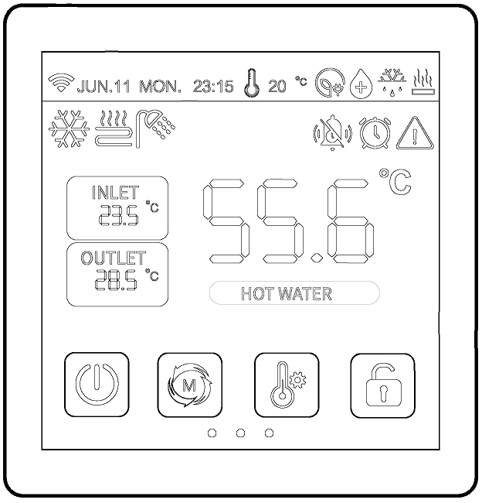

**IMPORTANT NOTE:**

Thank you very much for purchasing our product. Before using your unit, please read this manual carefully and keep it for future reference.

CONTENTS

[1. GENERAL SAFETY PRECAUTIONS 1](#_Toc23221)

[1.1. About The Documentation 1](#_Toc7883)

[1.2. For The User 1](#_Toc25944)

[2. GENERAL SAFETY PRECAUTION 2](#_Toc17840)

[2.1. The Appearance of The Wired Controller 2](#_Toc861)

[2.2. Status Icons 2](#_Toc32299)

[3. WIRE CONTROLLER OPERATION GUIDANCE 4](#_Toc17007)

[3.1. Main Interface 4](#_Toc9995)

[3.2. Key Operating Instruction 4](#_Toc13996)

[3.2.1. ON/OFF Function 4](#_Toc6745)

[3.2.2. Setting Water Temperature 4](#_Toc5848)

[3.2.3. Setting Mode 4](#_Toc19770)

[3.2.4. Lock/Unlock Function 5](#_Toc32551)

[3.2.5. Screen Saver / Screen Off 5](#_Toc8209)

[3.2.6. Check Parameter Status 5](#_Toc14192)

[3.2.7. Parameter Setting Interface 6](#_Toc26739)

[3.2.8. Setting Interface 6](#_Toc32697)

[3.2.9. Curve 7](#_Toc19431)

[3.2.10. Time Setting 8](#_Toc16009)

[3.2.11. Manual Mute 8](#_Toc31121)

[3.2.12. Timer ON/OFF Setting 9](#_Toc1633)

[3.2.13. Timed Sterilization Function 9](#_Toc558)

[3.2.14. Timed ON Lower Return Pump 10](#_Toc21566)

[3.2.15. Holiday Mode 10](#_Toc18710)

[3.2.16. Heating Function 11](#_Toc14119)

[3.2.17. Water Pump Operation Mode 12](#_Toc7705)

[3.2.18. Climate Curve 12](#_Toc20740)

[4. APPENDIX 15](#_Toc20336)

[4.1. Parameters 15](#_Toc25428)

[4.2. Error code 18](#_Toc15392)

[5. Wi-Fi FUNCTION 26](#_Toc28290)

[5.1. Software Installation 26](#_Toc29307)

[5.2. Login / Registration 26](#_Toc24802)

[5.3. Add Device 26](#_Toc933)

[5.4. Software Function Operation 29](#_Toc31395)

[5.5. Modify Device Name / Delete Device 31](#_Toc15432)

[5.6. Mode settings 32](#_Toc30258)

[5.7. Timing 32](#_Toc13272)

[5.8. Set Parameters 33](#_Toc16617)

[5.9. Mine 34](#_Toc28445)

# GENERAL SAFETY PRECAUTIONS

## About The Documentation

The original documentation is written in English. All other languages are translations.The precautions described in this document cover very important topics, follow them carefully.All activities described in the installation manual must be performed by an authorized installer.



|  |
| --- |
| WARNING |

* **WARNING:**Indicates a situation that could result in death or serious injury.
* **CAUTION:**Indicates a situation that could result in minor or moderate injury.
* **DANGER:**Indicates a situation that results in death or serious injury.
* **DANGER: RISK OF ELECTROCUTION:**Indicates a situation that could result in electrocution.
* **DANGER: RISK OF BURNING:**Indicates a situation that could result in burning because of extreme hot or cold temperatures.
* **NOTE:**Indicates a situation that could result in equipment or property damage.
* **INFORMATION:**Indicates useful tips or additional information.

## For The User

* If you are not sure how to operate the unit, contact your installer.
* The appliance is not intended for use by persons, including children, with reduced physical, sensory or mental capabilities, or lack of experience and knowledge, unless they have been given supervision or instruction concerning use of the appliance by a person responsible for their safety. Children must be supervised to ensure that they do not play with the product.
* Unit are marked with the following symbol:

This means that electrical and electronic products cannot be mixed with unsorted household waste. **Do NOT** try to dismantle the system yourself: the dismantling of the system, treatment of the refrigerant, of oil and of other parts must be done by an authorized installer and must comply with applicable legislation. Units must be treated at a specialized treatment facility for reuse, recycling and recovery. By ensuring this product is disposed of correctly, you will help to prevent potential negative consequences for the environment and human health. For more information, contact your installer or local authority.

* Placed in a location away from radiation.

# GENERAL SAFETY PRECAUTION

## The Appearance of The Wired Controller

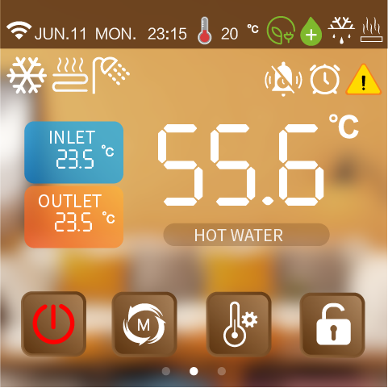

## Status Icons

| Icons | Status | Description | Icons | Status | Description |
| --- | --- | --- | --- | --- | --- |
|  | Network status | Display according to signal strength |  | Defrosting | Unit currently operating defrost function |
|  | Heating mode | Dynamically indicates power on | 资源 1437 | Anti-frost | Unit is currently operating with anti-freeze function |
|  | Cooling mode | Dynamically indicates power on | ~~资源 1438~~ | Holiday | Unit currently running in holiday mode |
|  | Automatic mode | Dynamically indicates power on |  | Quiet | The unit is currently running in silent mode |
|  | Hot water mode | Dynamically indicates power on | ~~资源 1440~~ | Energy saving | The unit is currently running in energy saving mode |
| 资源 1436 | Underfloor heating | Dynamically indicates power on | ~~资源 1441~~ | Capacity test | Unit currently running capacity test |
|  | Fault | Unit is faulty | ~~资源 1442~~ | Fluoride collection | Unit currently running fluoride collection function |
|  | Heating | Unit is currently running heating | 资源 1443 | antibacterial | Unit currently running sterilisation function |
|  | Network status | Blinking display distribution network | 资源 1444 | Free electricity |  |
|  | Timer Silence | The wire controller turns on the timed mute | 资源 1446 | Valley electricity |  |
|  | Timer function | The wire controller turns on the timed function | 资源 1445 | Peak electricity |  |

# WIRE CONTROLLER OPERATION GUIDANCE

## Main Interface

lALPDiQ3QLlF0RLMwMzA_192_192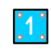

31393935333436313b31393936353331313bcafdd7d631393935333436313b31393936353331323bcafdd7d631393935333436313b31393936353331333bcafdd7d6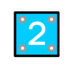

**Basic Icons**

1. Ambient temp.
2. Current mode
3. Inlet and outlet water temp.
4. ON/OFF
5. Mode
6. Target temp. setting
7. Lock/Unlock
8. Water tank temp. (Without hot water mode it will not appear.)
9. Timer mute ON/OFF, Timer ON/OFF, Fault
10. Electricity status, sterilization, defrosting, heating status.

## Key Operating Instruction

### ON/OFF Function

At the main interface,Short press "1625022605616_A1FA1042-3C81-401d-A849-E6461ED9FB33" .The pop-up window selects the working area to be turned on or off.

For example: the current unit supports dual zones, the pop-up window can select the content: Heating&Cooling, floor heating, hot water.

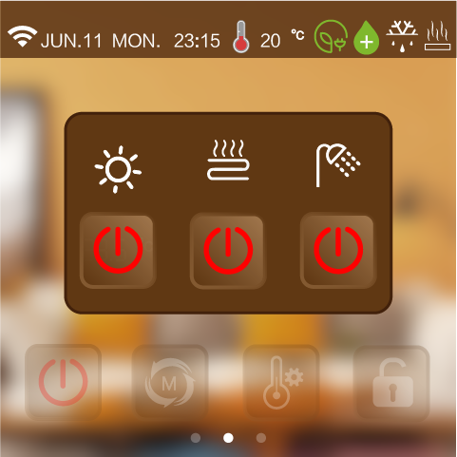

### Setting Water Temperature

At the main interface,Short press "", according to the current operation mode jump to the corresponding interface; for example: the current mode is heating + hot water, press "", enter the interface can only set the heating target temperature and hot water target temperature, the rest of the target temperature can not be set.

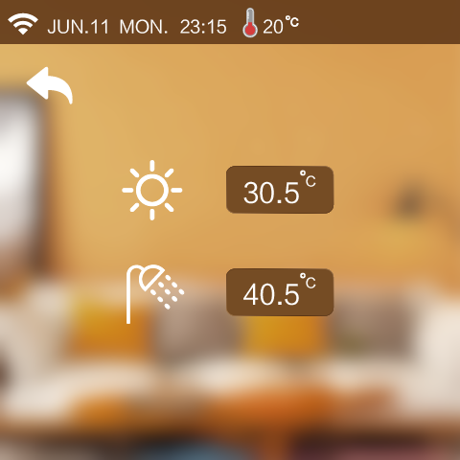

### Setting Mode

At the main interface,Short press "" mode key to jump to the corresponding interface according to the current mode supported by the unit; for example, if the unit only supports single heating, click the "" mode key to enter the interface with only the heating mode button.

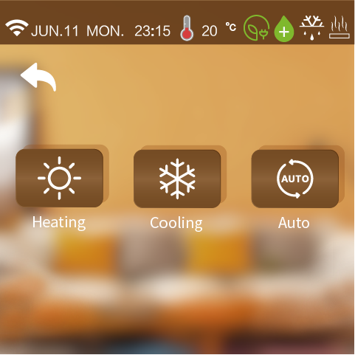

### Lock/Unlock Function

At the main interface, press “” to lock/unlock.

### Screen Saver / Screen Off

**1) Turn on the screen saver**

In all interfaces, for 60s without touching the screen, the screen brightness will automatically drop to 20% brightness, for 6min without touching the screen, the wire controller automatically jump to the screensaver interface, for 8min without touching the screen, the wire controller into a hibernation state.

Hibernation state, click on the screen wire controller bright screen display is still screensaver interface (only bright screen does not perform other actions).

The brightness of the controller 20% state: click on the screen controller brightness increased to 100% (Only bright screen does not perform other actions, and does not switch the interface.)

**2) Turn off the screen saver function**

In all interfaces, for 60s without touching the screen, the screen brightness will automatically drop to 20% brightness, for 6min without touching the screen, the wire controller into the hibernation state.

hibernation state, click on the screen controller bright screen display back to the main interface (Only bright screen does not perform other actions).

The brightness of the controller is 20%: click on the screen to increase the brightness of the controller to 100% (Only bright screen does not perform other actions, and does not switch the interface).

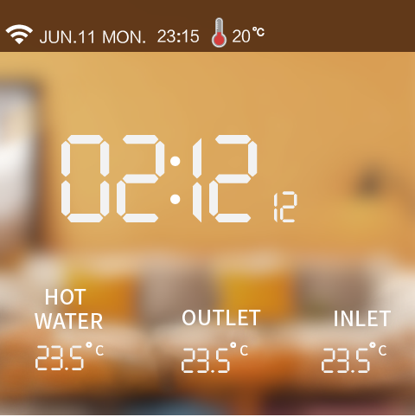

### Check Parameter Status

At the main interface, swipe from left to right to view the current operating status.

(When the temperature sensor fails, "--" will be displayed on the screen.)

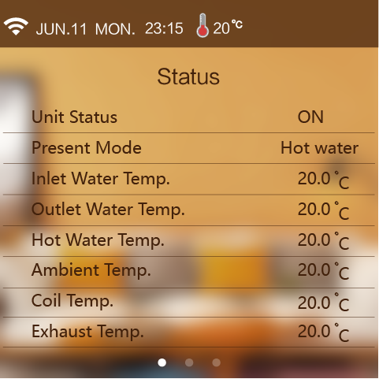

### Parameter Setting Interface

At the main interface, swipe from right to left to view the settings interface.

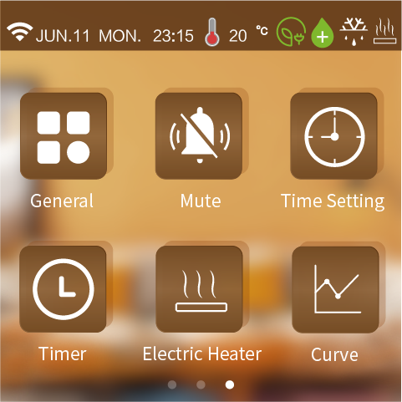

### Setting Interface

At the setting interface, press “1634089215723_C49680F4-F68F-4c31-90FB-15E4123606CF” to enter the system parameter interface.

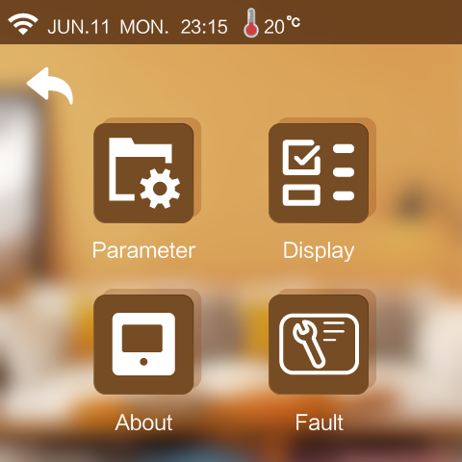

1. **Customer Management Interface**

At the system parameter interface, press “” and input the password “168” to enter the customer management interface.

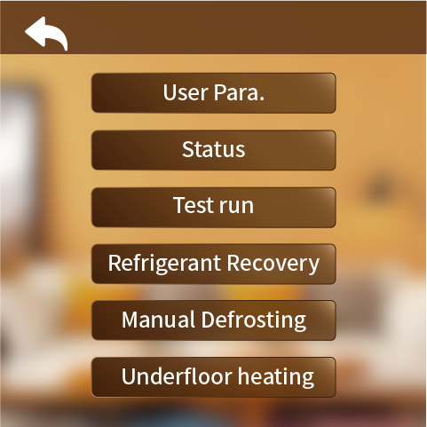

* **User parameter**

Press “User Para” to set the user parameter.

* **Status**

Press "Status" to view the system status of the unit.

* **Test run**

Press "Test run" for test run of unit function.

* **Manual Refrigerant Recovery**

1. Enter the Customer Parameters interface; (see "Customer Parameters Interface" for details.)

Click on "Refrigerant recovery".

* **Manual Defrosting**

1. Enter the Customer Parameters interface; (see "Customer Parameters Interface" for details.)
2. Click on "Manual Defrosting".
3. Select the module to be defrosted by yourself.

(The content of the displayed modules is determined by the "Number of modules" parameter, e.g. if the number of modules is 2, the current number of defrosting modules can be set to 2.)

* **Underfloor Heating**

Press "Underfloor Heating" to set the floor heating preheat function.

1. **Restore Default Setting Interface**

At the system parameter interface, press “” and input the password “400866” to enter the restore default setting interface.

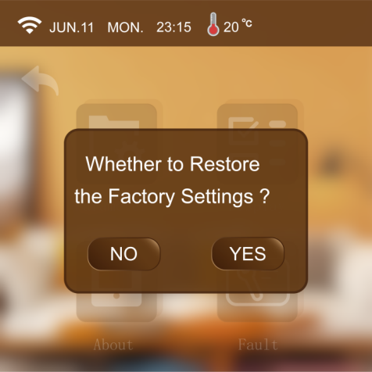

1. **Display Interface**

At the system parameter interface, press “1633954286181_68137627-C00B-460e-8CCF-B6E5F31B5C03” to enter the display interface.

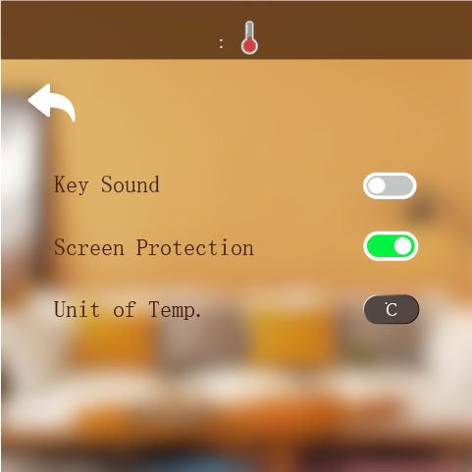

* **Key sound**

a) When sound is on: the buzzer sounds when the screen is tapped.

b) When sound is off: the buzzer does not sound when the screen is tapped.

* **Screen Protection**

Details can be found in 3.2.5

* **Unit of Temp.**

Each time the temperature unit is switched, the wire controller enters the read parameter interface and re-reads all the advanced parameters, returning to the setting interface after 20s.

1. **Information Interface**

At the system parameter interface, press “” to enter the information interface.

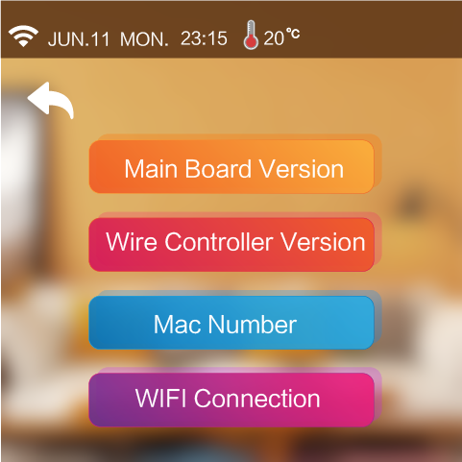

1. **History Fault**

At the system parameter interface, press “” and then input “168” to enter the history fault interface.

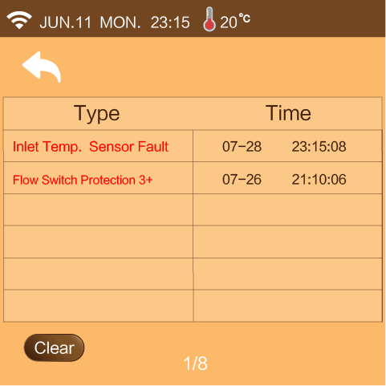

### Curve

At the setting interface, press “”to enter the curve interface.

* Every 20min to collect temp. data, every 1h to save the data. If less than 1h, the data within this period will not be saved.
* The temp. curve is with power-down memory function.

1. Celsius Temp.curve

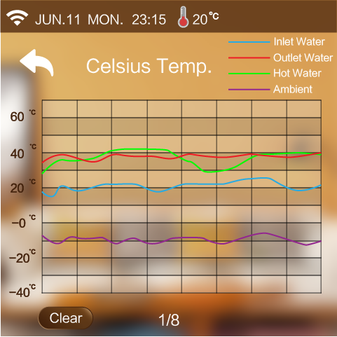

1. Fahrenheit Temp. curve

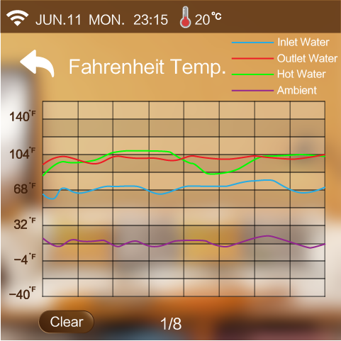

### Time Setting

At the setting interface, press “1634094324681_A739A288-3EC7-4737-BA84-53F3F484444A” to enter the time setting interface.

1. While the unit is ℉, the time setting interface is as follows:

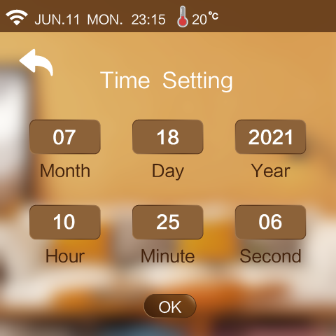

1. While the unit is℃, the time setting page is as follows:

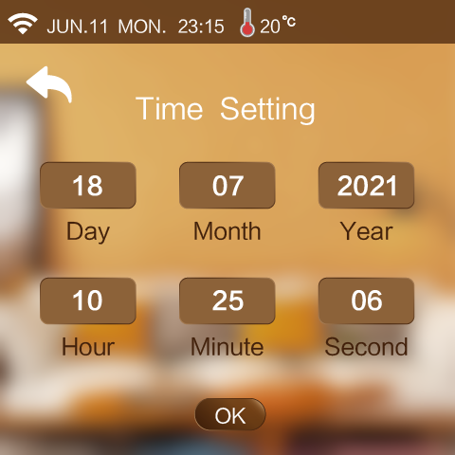

### Manual Mute

In the settings screen, press "lALPDgfLS3SsU0l2eQ_121_118" enter the mute function .

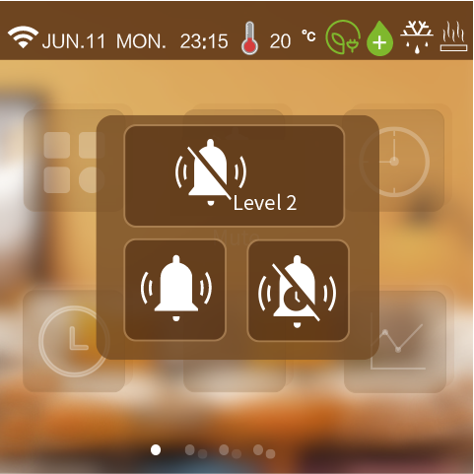

1. **Mute Level**

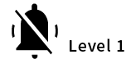:Indicates that the unit is currently in the first level of silence.

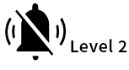:Indicates that the unit is currently in secondary silence.

1. **Mute Mode**

:Indicates that the unit is not currently muted.

:Indicates that the unit is currently muted.

1. **Timer Mute**

Press “lALPDgfLS3SsU0l2eQ_121_118” to enter the timer mute setting interface.

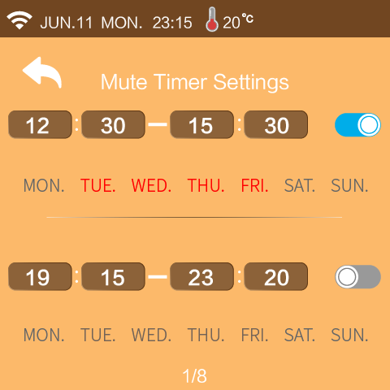

1. Mute setting start time
2. Mute setting end time
3. While the mute setting is valid, the background is blue;

While the mute setting is invalid, the background is gray.

1. Press MON~SUN to choose which day to be valid for the timer. The day will become red after pressing.

**Note:**If timed on time is equal to timed off time, the segment cannot take effect.

If timing is not on or the timing on week is not selected, the segment of timing cannot take effect.

If the timings are set to cross, the opening time or end time will be executed according to the earliest time.

### Timer ON/OFF Setting

At the setting interface, click " 1633935330687_C301CD88-1A4D-48c6-8984-293B47DAA476 " and then click "Timer Switch" to enter the Timer ON/OFF setting interface.

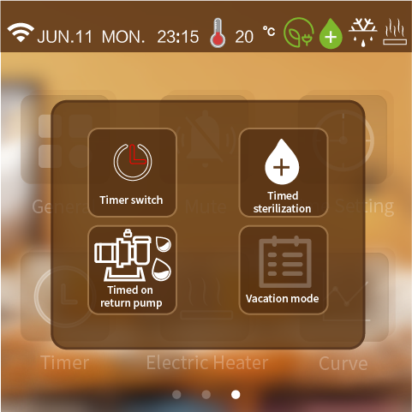

" 资源 1457 " indicates that the timer switch function is on," 资源 1458 " indicates that the timer switch function is not on," 资源 1459 " indicates that the unit does not have a timer on/off function.

**Note:**If timed on time is equal to timed off time, the segment cannot take effect.

If timing is not on or the timing on week is not selected, the segment of timing cannot take effect.

If the timings are set to cross, the opening time or end time will be executed according to the earliest time.

### Timed Sterilization Function

At the setting interface, press "1633935330687_C301CD88-1A4D-48c6-8984-293B47DAA476" in the settings screen, then press"Timed Sterilization" Enter the timed sterilization function.

**Operating conditions:**Turn on sterilization parameters



" 资源 1447 " indicates that the timer sterilization function is on, " 资源 1455 " indicates that the timer sterilization function is off, " 资源 1460 " indicates that the unit does not have the timer sterilization function.

**Note:**Timing is on for the day of the week, otherwise the timing will not work.

### Timed ON Lower Return Pump

At the setting interface, press "1633935330687_C301CD88-1A4D-48c6-8984-293B47DAA476" in the settings screen, then press"Timed on return pump" enter the timed turn-on of the lower return pump.

**Operating conditions:**Turn on the lower return pump parameters.



" 资源 1448 "indicates that the timed pump-down function is enabled, " 资源 1450"indicates that the timed pump-down function is not enabled,

" 资源 1449" indicates that the unit does not have a timed pump-down function.

### Holiday Mode

At the setting interface, press "1633935330687_C301CD88-1A4D-48c6-8984-293B47DAA476" in the settings screen, then press "lQLPJxxW4yQkjjQYGLB3rsdLhndQUgOwlN9bgHYA_24_24" select holiday mode.

**Operating conditions:** The heating mode of the unit is enabled, otherwise it cannot enter the holiday mode.



" 资源 1451"indicates that the timed holiday function is enabled, " 资源 1452"indicates that the timed holiday function is not enabled, " 资源 1454" indicates that the unit does not have the timed holiday function.

**Note:** When holiday leave home mode and holiday at home mode are turned on at the same time, holiday leave mode is the highest authority. Holiday enter when executing the holiday mode when executing the target temperature, exit holiday mode to execute the normal setting target temperature, enter the holiday mode when not allowed to operate the line controller, operation of the line controller will pop-up window whether to exit the holiday mode.

**Use scenarios:**

a) Holiday at home mode: you can set the indoor temperature and water temperature for each time period (for example: the temperature is colder in the early morning you can set a period of time to set the target temperature higher, the temperature is more suitable at noon you can set a period of time to set the target temperature lower, the temperature drops in the evening set a period of time to set the target temperature higher).

b) Holiday leave mode: when no one lives at home, you can keep the room a minimum temperature operation.

### Heating Function

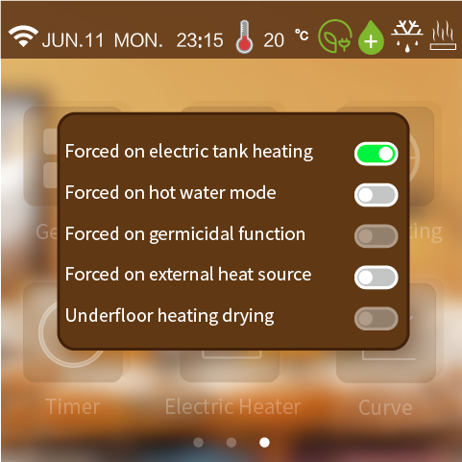

1. **Electric tank heating**

At the setting interface, press “” to enter the electric heater interface.

**Operating conditions:**

a) The unit is turned on the hot water function and the current operation contains hot water mode.

b) If the hot water temperature of the unit > the target temperature of hot water, the hot water temperature of the unit < the target temperature of hot water - the hot water will be poor.

c) Unit hot water temperature < hot water target temperature - 1°

d) The electric tank heating function is enabled.

e) If one of the conditions a-d is not met, the electric heater cannot be forced on.

1. **Force On Hot water mode**

At the setting interface, press “” to enter the electric heater interface.

**Operating conditions:**

The unit turns on the hot water function, otherwise it cannot be turned on to forced hot water mode.

The unit turns on the hot water function, otherwise it cannot be turned on to forced hot water mode.

1. **Forced on germicidal function**

At the setting interface, press “” to enter the one-touch heat collection function interface.

**Operating conditions:**

The unit turns on the Sterilization function, otherwise it cannot be turned on to forced sterilization mode.

1. **Forced on external heat source**

At the setting interface, press “” to enter the electric heater interface.

**Operating conditions:**

The unit turns on the external heat source, otherwise it cannot be turned on to forced external heat source mode.

1. **Underfloor heating drying**

At the setting interface, press “” to enter the electric heater interface.

**Operating conditions:**

The unit underfloor heating inlet temperature sensor on, otherwise the underfloor heating drying function cannot be switched on.

### Water Pump Operation Mode

At the system parameter interface, press “” and input the password “168” to enter the customer management interface.Click P01 parameter to modify the pump operation mode.You can choose Always running/intermittent operation/stop temp. Reached.

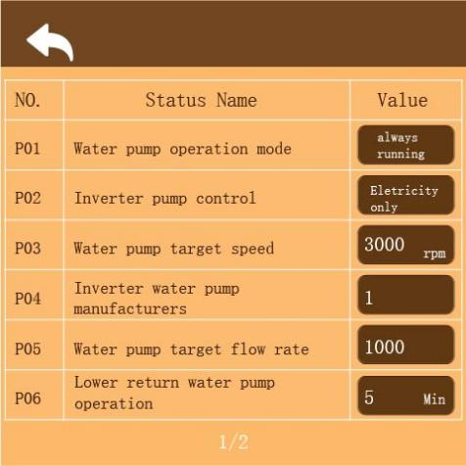

### Climate Curve

At the system parameter interface, press “” and input the password “168” to enter the customer management interface. Setting parameters M10-M21.

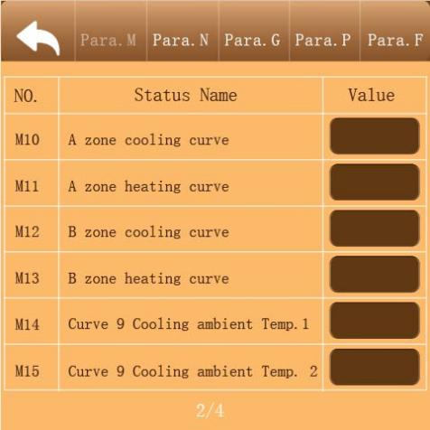 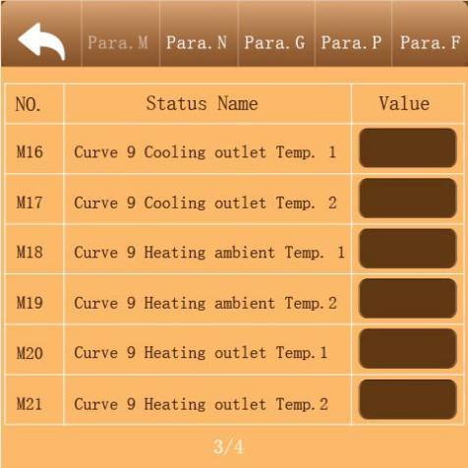

**1. Cooling climate curve**

a) Users can choose to enable any one curve according to the following table.

b) Users can set the curve parameters by themselves, set the parameters as follows: Curve 9 Cooling Ambient Temp.1, Curve 9 Cooling Ambient Temp.2,Curve 9 Cooling Outlet Temp.1,Curve 9 Cooling Outlet Temp.2.(The target temperature value is calculated according to the linear relationship y=kx+b.)

|  |  |  |  |  |
| --- | --- | --- | --- | --- |
| **Ambient Temp** | **-10≤TA＜15** | **15≤TA＜22** | **22≤TA＜30** | **30≤TA** |
| **Low Temp.1** | 16 | 11 | 8 | 5 |
| **Low Temp.2** | 17 | 12 | 9 | 6 |
| **Low Temp.3** | 18 | 13 | 10 | 7 |
| **Low Temp.4** | 19 | 14 | 11 | 8 |
| **Low Temp.5** | 20 | 15 | 12 | 9 |
| **Low Temp.6** | 21 | 16 | 13 | 10 |
| **Low Temp.7** | 22 | 17 | 14 | 11 |
| **Low Temp.8** | 23 | 18 | 15 | 12 |
| **High Temp.1** | 20 | 18 | 17 | 16 |
| **High Temp.2** | 21 | 19 | 18 | 17 |
| **High Temp.3** | 22 | 20 | 19 | 17 |
| **High Temp.4** | 23 | 21 | 19 | 18 |
| **High Temp.5** | 24 | 21 | 20 | 18 |
| **High Temp.6** | 24 | 22 | 20 | 19 |
| **High Temp.7** | 25 | 22 | 21 | 19 |
| **High Temp.8** | 25 | 23 | 21 | 20 |

**2. Heating climate curve**

a) Users can choose to enable any one curve according to the following table.

b) Users can set the curve parameters by themselves, set the parameters as follows: Curve 9 Heating Ambient Temp.1, Curve 9 Heating Ambient Temp.2,Curve 9 Heating Outlet Temp.1,Curve 9 Heating Outlet Temp.2.(The target temperature value is calculated according to the linear relationship y=kx+b.)

|  |  |  |  |  |  |  |  |  |  |  |  |  |  |  |  |  |  |
| --- | --- | --- | --- | --- | --- | --- | --- | --- | --- | --- | --- | --- | --- | --- | --- | --- | --- |
| **Ambient Temp.** | **≤-20** | **-19** | **-18** | **-17** | **-16** | **-15** | **-14** | **-13** | **-12** | **-11** | **-10** | **-9** | **-8** | **-7** | **-6** | **-5** | **-4** |
| **Low Temp.1** | 38 | 38 | 38 | 38 | 38 | 37 | 37 | 37 | 37 | 37 | 37 | 36 | 36 | 36 | 36 | 36 | 36 |
| **Low Temp.2** | 37 | 37 | 37 | 37 | 37 | 36 | 36 | 36 | 36 | 36 | 36 | 35 | 35 | 35 | 35 | 35 | 35 |
| **Low Temp.3** | 36 | 36 | 36 | 35 | 35 | 35 | 35 | 35 | 35 | 34 | 34 | 34 | 34 | 34 | 34 | 33 | 33 |
| **Low Temp.4** | 35 | 35 | 35 | 34 | 34 | 34 | 34 | 34 | 34 | 33 | 33 | 33 | 33 | 33 | 33 | 32 | 32 |
| **Low Temp.5** | 34 | 34 | 34 | 33 | 33 | 33 | 33 | 33 | 33 | 32 | 32 | 32 | 32 | 32 | 32 | 31 | 31 |
| **Low Temp.6** | 32 | 32 | 32 | 32 | 31 | 31 | 31 | 31 | 31 | 31 | 31 | 31 | 30 | 30 | 30 | 30 | 30 |
| **Low Temp.7** | 31 | 31 | 31 | 31 | 30 | 30 | 30 | 30 | 30 | 30 | 30 | 30 | 29 | 29 | 29 | 29 | 29 |
| **Low Temp.8** | 29 | 29 | 29 | 29 | 28 | 28 | 28 | 28 | 28 | 28 | 28 | 28 | 27 | 27 | 27 | 27 | 27 |
| **High Temp.1** | 55 | 55 | 55 | 55 | 54 | 54 | 54 | 54 | 54 | 54 | 54 | 54 | 53 | 53 | 53 | 53 | 53 |
| **High Temp.2** | 53 | 53 | 53 | 53 | 52 | 52 | 52 | 52 | 52 | 52 | 52 | 52 | 51 | 51 | 51 | 51 | 51 |
| **High Temp.3** | 52 | 52 | 52 | 52 | 51 | 51 | 51 | 51 | 51 | 51 | 51 | 51 | 50 | 50 | 50 | 50 | 50 |
| **High Temp.4** | 50 | 50 | 50 | 50 | 49 | 49 | 49 | 49 | 49 | 49 | 49 | 49 | 48 | 48 | 48 | 48 | 48 |
| **High Temp.5** | 48 | 48 | 48 | 48 | 47 | 47 | 47 | 47 | 47 | 47 | 47 | 47 | 46 | 46 | 46 | 46 | 46 |
| **High Temp.6** | 45 | 45 | 45 | 45 | 44 | 44 | 44 | 44 | 44 | 44 | 44 | 44 | 43 | 43 | 43 | 43 | 43 |
| **High Temp.7** | 43 | 43 | 43 | 43 | 42 | 42 | 42 | 42 | 42 | 42 | 42 | 42 | 41 | 41 | 41 | 41 | 41 |
| **High Temp.8** | 40 | 40 | 40 | 40 | 39 | 39 | 39 | 39 | 39 | 39 | 39 | 39 | 38 | 38 | 38 | 38 | 38 |
| **Ambient Temp.** | **-3** | **-2** | **-1** | **0** | **1** | **2** | **3** | **4** | **5** | **6** | **7** | **8** | **9** | **10** | **11** | **12** | **13** |
| **Low Temp.1** | 35 | 35 | 35 | 35 | 35 | 35 | 34 | 34 | 34 | 34 | 34 | 34 | 33 | 33 | 33 | 33 | 33 |
| **Low Temp.2** | 34 | 34 | 34 | 34 | 34 | 34 | 33 | 33 | 33 | 33 | 33 | 33 | 32 | 32 | 32 | 32 | 32 |
| **Low Temp.3** | 33 | 33 | 33 | 33 | 32 | 32 | 32 | 32 | 32 | 32 | 31 | 31 | 31 | 31 | 31 | 31 | 30 |
| **Low Temp.4** | 32 | 32 | 32 | 32 | 31 | 31 | 31 | 31 | 31 | 31 | 30 | 30 | 30 | 30 | 30 | 30 | 29 |
| **Low Temp.5** | 31 | 31 | 31 | 31 | 30 | 30 | 30 | 30 | 30 | 30 | 29 | 29 | 29 | 29 | 29 | 29 | 28 |
| **Low Temp.6** | 30 | 30 | 30 | 29 | 29 | 29 | 29 | 29 | 29 | 29 | 28 | 28 | 28 | 28 | 28 | 28 | 27 |
| **Low Temp.7** | 29 | 29 | 29 | 28 | 28 | 28 | 28 | 28 | 28 | 28 | 27 | 27 | 27 | 27 | 27 | 27 | 26 |
| **Low Temp.8** | 27 | 27 | 27 | 26 | 26 | 26 | 26 | 26 | 26 | 26 | 26 | 25 | 25 | 25 | 25 | 25 | 25 |
| **High Temp.1** | 53 | 53 | 53 | 53 | 53 | 52 | 52 | 52 | 52 | 52 | 52 | 52 | 52 | 51 | 51 | 51 | 51 |
| **High Temp.2** | 51 | 51 | 51 | 51 | 51 | 50 | 50 | 50 | 50 | 50 | 50 | 50 | 50 | 49 | 49 | 49 | 49 |
| **High Temp.3** | 50 | 50 | 50 | 50 | 50 | 49 | 49 | 49 | 49 | 49 | 49 | 49 | 49 | 48 | 48 | 48 | 48 |
| **High Temp.4** | 48 | 48 | 48 | 48 | 48 | 47 | 47 | 47 | 47 | 47 | 47 | 47 | 47 | 46 | 46 | 46 | 46 |
| **High Temp.5** | 46 | 46 | 46 | 46 | 46 | 45 | 45 | 45 | 45 | 45 | 45 | 45 | 45 | 44 | 44 | 44 | 44 |
| **High Temp.6** | 43 | 43 | 43 | 43 | 43 | 42 | 42 | 42 | 42 | 42 | 42 | 42 | 42 | 41 | 41 | 41 | 41 |
| **High Temp.7** | 41 | 41 | 41 | 41 | 41 | 40 | 40 | 40 | 40 | 40 | 40 | 40 | 40 | 39 | 39 | 39 | 39 |
| **High Temp.8** | 38 | 38 | 38 | 38 | 38 | 37 | 37 | 37 | 37 | 37 | 37 | 37 | 37 | 36 | 36 | 36 | 36 |
| **Ambient Temp.** | **14** | **15** | **16** | **17** | **18** | **19** | **≥20** |  |  |  |  |  |  |  |  |  |  |
| **Low Temp.1** | 33 | 32 | 32 | 32 | 32 | 32 | 32 |  |  |  |  |  |  |  |  |  |  |
| **Low Temp.2** | 32 | 31 | 31 | 31 | 31 | 31 | 31 |  |  |  |  |  |  |  |  |  |  |
| **Low Temp.3** | 30 | 30 | 30 | 30 | 30 | 29 | 29 |  |  |  |  |  |  |  |  |  |  |
| **Low Temp.4** | 29 | 29 | 29 | 29 | 29 | 28 | 28 |  |  |  |  |  |  |  |  |  |  |
| **Low Temp.5** | 28 | 28 | 28 | 28 | 28 | 27 | 27 |  |  |  |  |  |  |  |  |  |  |
| **Low Temp.6** | 27 | 27 | 27 | 27 | 27 | 26 | 26 |  |  |  |  |  |  |  |  |  |  |
| **Low Temp.7** | 26 | 26 | 26 | 26 | 26 | 25 | 25 |  |  |  |  |  |  |  |  |  |  |
| **Low Temp.8** | 25 | 25 | 24 | 24 | 24 | 24 | 24 |  |  |  |  |  |  |  |  |  |  |
| **High Temp.1** | 51 | 51 | 50 | 50 | 50 | 50 | 50 |  |  |  |  |  |  |  |  |  |  |
| **High Temp.2** | 49 | 49 | 48 | 48 | 48 | 48 | 48 |  |  |  |  |  |  |  |  |  |  |
| **High Temp.3** | 48 | 48 | 47 | 47 | 47 | 47 | 47 |  |  |  |  |  |  |  |  |  |  |
| **High Temp.4** | 46 | 46 | 45 | 45 | 45 | 45 | 45 |  |  |  |  |  |  |  |  |  |  |
| **High Temp.5** | 44 | 44 | 43 | 43 | 43 | 43 | 43 |  |  |  |  |  |  |  |  |  |  |
| **High Temp.6** | 41 | 41 | 40 | 40 | 40 | 40 | 40 |  |  |  |  |  |  |  |  |  |  |
| **High Temp.7** | 39 | 39 | 38 | 38 | 38 | 38 | 38 |  |  |  |  |  |  |  |  |  |  |
| **High Temp.8** | 36 | 36 | 35 | 35 | 35 | 35 | 35 |  |  |  |  |  |  |  |  |  |  |

# APPENDIX

## Parameters

**Note:** Parameters can only be modified when the unit is powered off, otherwise the parameters cannot be modified successfully.

|  |  |  |  |
| --- | --- | --- | --- |
| **Code** | **Parameter** | **Unit** | **Range** |
| N01 | Power mode | / | 0 Standard/1 Powerful/2 Energy saving/3 Auto |
| N02 | Air conditioner type | / | 0 Separate heating/1 Heating & Cooling / 2 Separate cooling |
| N04 | Four-way valve setting | / | 0 Heating open valve/1 Cooling open valve |
| N05 | Wire control switch type | / | 0 Toggle switch/1 Pulse switch |
| N06 | Unit start/stop control | / | 0 Union/1 Remote/2 Local/3 In-line control/4 Net control |
| N07 | Power down memory switch | / | 0 Prohibition/1 Use |
| N08 | Incoming self-start | / | 0 Prohibition/1 Use |
| N23 | Linkage function setting | / | 0 Prohibited/1 Linkage active/2 Linkage closure active/3 Display switch on/off/4 Display water tank electric heater/5 Display external heat source |
| N32 | Smart grid function | / | 0 Prohibition/1 Use |
| N38 | EVU PV signal | / | 0 Normally open/1 Normally closed |
| N39 | SG grid signal | / | 0 Normally open/1 Normally closed |
| M01 | Cooling setting Temp. | ℃ | 15～35 |
| M02 | Heating setting Temp. | ℃ | 0～85 |
| M03 | Hot water setting Temp. | ℃ | 0～80 |
| M08 | Heating setting Temp.(B) | ℃ | 40～60 |
| M10 | A zone cooling curve | / | 0 Prohibited/ 1 TL1/ 2 TL2/ 3 TL3/4 TL4/ 5 TL5/ 6 TL6/ 7 TL7/ 8 TL8/ 9 TH9/ 10 TH10/ 11 TH11/ 12 TH12/ 13 TH13/ 14 TH14/ 15 TH15/ 16 TH16/ 17 TH17/ Customised Curve |
| M11 | A zone heating curve | / | 0 Prohibited/ 1 TL1/ 2 TL2/ 3 TL3/ 4 TL4/ 5 TL5/ 6 TL6/ 7 TL7/ 8 TL8/ 9 TH9/ 10 TH10/ 11 TH11/ 12 TH12/ 13 TH13/ 14 TH14/ 15 TH15/ 16 TH16/ 17 TH17/ Customised Curve |
| M12 | B zone cooling curve | / | 0 Prohibited/ 1 TL1/ 2 TL2/ 3 TL3/ 4 TL4/ 5 TL5/ 6 TL6/ 7 TL7/ 8 TL8/ 9 TH9/ 10 TH10/ 11 TH11/ 12 TH12/ 13 TH13/ 14 TH14/ 15 TH15/ 16 TH16/ 17 TH17/ Customised Curve |
| M13 | B zone heating curve | / | 0 Prohibited/ 1 TL1/ 2 TL2/ 3 TL3/ 4 TL4/ 5 TL5/ 6 TL6/ 7 TL7/ 8 TL8/ 9 TH9/ 10 TH10/ 11 TH11/ 12 TH12/ 13 TH13/ 14 TH14/ 15 TH15/ 16 TH16/ 17 TH17/ Customised Curve |
| M14 | Curve 9 Cooling ambient Temp.1 | ℃ | -5～46 |
| M15 | Curve 9 Cooling ambient Temp. 2 | ℃ | -5～46 |
| M16 | Curve 9 Cooling outlet Temp. 1 | ℃ | 5～25 |
| M17 | Curve 9 Cooling outlet Temp. 2 | ℃ | 5～25 |
| M18 | Curve 9 Heating ambient Temp. 1 | ℃ | -25～35 |
| M19 | Curve 9 Heating ambient Temp.2 | ℃ | -25～35 |
| M20 | Curve 9 Heating outlet Temp.1 | ℃ | 25～65 |
| M21 | Curve 9 Heating outlet Temp.2 | ℃ | 25～65 |
| M35 | Min. ambient Temp.of automatic cooling | ℃ | 20～29 |
| M36 | Max. ambient Temp.of automatic cooling | ℃ | 10～17 |
| M37 | Holiday away from home heating | ℃ | 20～25 |
| M38 | Holiday away from home hot water | ℃ | 20～25 |
| M39 | Auxiliary electric heater | / | 0 Disable/1 Heating only/2 Hot water only/3 Heating & Hot water |
| M40 | External heat source | / | 0 Disable/1 Heating only/2 Hot water only/3 Heating & Hot water |
| M55 | Floor heating preheating Temp. | ℃ | 25～35 |
| M56 | Floor heating preheating interval | Min | 10～40 |
| M57 | Floor heating preheating duration | H | 48～96 |
| M58 | Floor heating water Temp. return | ℃ | 0～10 |
| M59 | Floor heating room Temp. return | ℃ | 0～10 |
| M60 | Floor heating before drying | DAY | 4～15 |
| M61 | Floor heating during drying | DAY | 3～7 |
| M62 | Floor heating after drying | DAY | 4～15 |
| M63 | Floor heating drying Temp. | ℃ | 30～55 |
| F06 | Variable frequency fan speed adjustment | / | 0 Manual / 1 Ambient Temp. linear / 2 Fin Temp. linear |
| F07 | Fan manual operation | rps |  |
| P01 | Water pump operation mode | / | 0 Always running / 1 Stop Temp. reached / 2 Intermittent operation |
| P02 | Inverter pump control | / | 1 Control of speed / 2 Control of flow / 3 Power only / 4 Control of power |
| P03 | Water pump target speed | rpm | 1000～4500 |
| P04 | Inverter water pump manufacturers | / | 0～4 |
| P05 | Water pump target flow rate | undefined | 0～4500 |
| P06 | Lower return water pump operation | Min | 5～120 |
| P07 | Lower return pump sterilization | / | 0 Prohibit/1 Use |
| P08 | Lower return pump timing | / | 0 Prohibit/1 Use |

## Error code

| **Code** | **Description** | **Causes** | **Solutions** |
| --- | --- | --- | --- |
| E01 | Wire controller communication fault | 1.The connection between wire controller and main board is poor. 2. Wire controller fault. 3. Main board fault. 4. Communication wire and strong electricity wire put together, resulting in power interference communication | 1. Reconnect the wire controller cable. 2. Replace the wire controller. 3. Replace the main board. 4. Communication wire is placed separately from the strong electricity wire. |
| E03 | 0#Compressor high pressure | 1. Check for refrigerant leaks 2. The throttle device is dirty and blocked, damaged 3. Compressor bearing damage, causing mechanical part friction, exhaust temperature rise 4. High pressure switch fault 5. Main board fault 6. Compressor fault | 1.Refill refrigerant 2.Clean/replace throttle device 3.Replace compressor 4.Replace the high pressure switch 5.Replace the main board 6.Replace the compressor |
| E04 | 0#Compressor low pressure | 1.Insufficient water flow 2.Low chilled water inlet water temperature 3.Refrigerant leakage or insufficient refrigerant charge 4.Scale in evaporator | 1.Check the temperature difference between the inlet and outlet water and adjust the water flow 2.Check the installation 3.Leak detection or filling with sufficient refrigerant 4.Remove water scale |
| E06 | 0#Inverter communication failure | 1. Power supply voltage fault 2. Inverter board fault 3. Main board fault | 1. Replace the power cord 2. Replace the inverter board 3.Replace the main board |
| E06 | 0#Communication fault | 1. Communication lines and strong wires placed together, resulting in communication power interference 2. Poor connection between the module machine and the main board. 3. Main board fault | 1.Communication wire is placed separately from the strong electricity wire. 2.Reconnect the wires 3.Replace the main board. |
| E10 | Floor heating water inlet temperature fault | 1.Whether the wiring is loose/damaged 2.Temperature sensor fault 3.Main board fault | 1.Rewiring/replacement of wires 2. Replace the temperature sensor 3. Replace the main board |
| E11 | Total outlet water temperature fault | 1.Whether the wiring is loose/damaged 2.Temperature sensor fault 3.Main board fault | 1.Rewiring/replacement of wires 2. Replace the temperature sensor 3. Replace the main board |
| E11 | System total outlet water temperature fault | 1.Whether the wiring is loose/damaged 2.Temperature sensor fault 3.Main board fault | 1.Rewiring/replacement of wires 2. Replace the temperature sensor 3. Replace the main board |
| E11 | 0#Plate exchanger outlet water Temp. fault | 1.Whether the wiring is loose/damaged 2.Temperature sensor fault 3.Main board fault | 1.Rewiring/replacement of wires 2. Replace the temperature sensor 3. Replace the main board |
| E11 | 0# Total water outlet Temp. fault | 1.Whether the wiring is loose/damaged 2.Temperature sensor fault 3.Main board fault | 1.Rewiring/replacement of wires 2. Replace the temperature sensor 3. Replace the main board |
| E12 | Hot water tank temperature fault | 1.Whether the wiring is loose/damaged 2.Temperature sensor fault 3.Main board fault | 1.Rewiring/replacement of wires 2. Replace the temperature sensor 3. Replace the main board |
| E12 | Buffer tank upper temperature fault | 1.Whether the wiring is loose/damaged 2.Temperature sensor fault 3.Main board fault | 1.Rewiring/replacement of wires 2. Replace the temperature sensor 3. Replace the main board |
| E12 | Buffer tank lower temperature fault | 1.Whether the wiring is loose/damaged 2.Temperature sensor fault 3.Main board fault | 1.Rewiring/replacement of wires 2. Replace the temperature sensor 3. Replace the main board |
| E13 | Indoor temperature fault | 1.Whether the wiring is loose/damaged 2.Temperature sensor fault 3.Main board fault | 1.Rewiring/replacement of wires 2. Replace the temperature sensor 3. Replace the main board |
| E14 | 0# Ambient Temp. fault | 1.Whether the wiring is loose/damaged 2.Temperature sensor fault 3.Main board fault | 1.Rewiring/replacement of wires 2. Replace the temperature sensor 3. Replace the main board |
| E16 | 0#Exhaust temperature failure | 1.Whether the wiring is loose/damaged 2.Temperature sensor fault 3.Main board fault | 1.Rewiring/replacement of wires 2. Replace the temperature sensor 3. Replace the main board |
| E21 | EEPROM data error | Data reading error | Shutdown and restart |
| E21 | 0#EEPROM data error |
| E24 | 0#High plate return water temperature | 1.Whether the wiring is loose/damaged 2.Heat exchanger is blocked 3.Temperature sensor fault 4.Main board fault | 1.Rewiring/replacement of wires 2.Cleaning of heat exchangers 3.Replace the temperature sensor 4.Replace the main board |
| E24 | 0#Plate exchanger outlet water Temp. too high | 1. Low water flow  2. Clogged water pipes  3. Water pipe damage  4. Sensor fault | 1. Clear the blockage  2. Check whether the water flow of the pump meets the requirements  3. Replace the water pipe  4. Replace the sensor |
| E25 | 0#Cooling evaporation is too low |
| E25 | 0#Low plate return water temperature |
| E25 | 0#Plate exchanger outlet water Temp. too low |
| E26 | 0# Out and return water Temp. difference is too large |
| E26 | 0#Out and return water Temp. difference abnormal |
| E27 | 0#Exhaust temperature too high |
| E31 | 0#J5 pressure sensor fault | 1.Whether the wiring is loose/damaged 2.Temperature sensor fault 3.Main board fault | 1.Rewiring/replacement of wires 2. Replace the temperature sensor 3. Replace the main board |
| E32 | 0#J6 pressure sensor fault | 1.Whether the wiring is loose/damaged 2.Temperature sensor fault 3.Main board fault | 1.Rewiring/replacement of wires 2. Replace the temperature sensor 3. Replace the main board |
| E44 | 0# Plate exchanger return water Temp. fault | 1.Whether the wiring is loose/damaged 2.Temperature sensor fault 3.Main board fault | 1.Rewiring/replacement of wires 2. Replace the temperature sensor 3. Replace the main board |
| E55 | 0#Suction temperature failure | 1.Whether the wiring is loose/damaged 2.Temperature sensor fault 3.Main board fault | 1.Rewiring/replacement of wires 2. Replace the temperature sensor 3. Replace the main board |
| E56 | Solar Temp. sensor fault | 1.Whether the wiring is loose/damaged 2.Temperature sensor fault 3.Main board fault | 1.Rewiring/replacement of wires 2. Replace the temperature sensor 3. Replace the main board |
| E58 | 0#Fin temperature failure | 1.Whether the wiring is loose/damaged 2.Temperature sensor fault 3.Main board fault | 1.Rewiring/replacement of wires 2. Replace the temperature sensor 3. Replace the main board |
| E59 | 0#Suction temperature too low | 1. Too much/too little refrigerant 2.Temperature sensor fault 3. Main board fault | 1.Refill the refrigerant according to the nameplate 2.Replace the temperature sensor 3.Replace the main board |
| E60 | 0#Frequent emergency defrost | 1. Ambient temperature sensor is damaged 2.Dirty and blocked heat exchanger 3. Lack of refrigerant | 1.Replace the ambient temperature sensor 2.Clean the heat exchanger 3.Refill the refrigerant according to the nameplate |
| E61 | 0#Abnormal Temp. difference between suction and exhaust | 1.Inlet and outlet water temp. sensor fault. 2.The valve in water system is not open. 3.Waterway blockage, may appear in the heat exchanger or valve part. 4.Improper water pump selection 5.The water pump is broken . 6.Pipe size is too small. 7.Heat exchanger is fouling. | 1. Need to replace the temp. sensor. 2.Clean or replace the blocked part. 3.Change the pump according to the water flow and water head. 4.Need to change the water pipe. 5.Reset the water flow switch manually. 6.Choose the suitable pipe size. 7.Clean the dirt of the heat exchanger surface. |
| E62 | Fan coil communication fault 1-32 | 1. Connection cable fault 2. Power input fault 3. Main board fault | 1. Check wiring and rewire 2. Replace the power cord 3. Replace the main board |
| E63 | 0#Communication abnormal | 1. Communication lines and strong wires placed together, resulting in communication power interference 2. Poor connection between the module machine and the main board. 3. Main board fault | 1.Communication wire is placed separately from the strong electricity wire. 2.Reconnect the wires 3.Replace the main board. |
| E63 | 0#Internal and external machine communication failure |
| E64 | 0#Protocol version too low | Program error | Update procedure |
| E65 | 0#Abnormal model setting | 1. Main board code error 2. The program did not restore the factory settings | 1.Resetting the main board code 2.Re-download the program |
| E66 | System maintenance data error | System maintenance data error | Recovery parameters in parameter setting |
| E67 | Water tank electric heating overload | 1.Voltage input error 2.Water tank damage | 1.Check power supply wiring/reconnect power supply voltage 2.Repair of water tank |
| E67 | 0#Auxiliary electric heater overload |
| E68 | 0# Insufficient water flow | 1.The water system is blocked 2.Water pump is not suitable 3. Water pipe is small  4.The water flow switch is stuck and cannot be reset. | 1.Check if the pump is running properly/Clean or replace the blocked part 2.Change the pump according to the water flow and water head 3.Need to change the water pipe 4.Reset the water flow switch manually. |
| E69 | 0# Refrigerant gas side Temp. fault | 1.Whether the wiring is loose/damaged 2.Temperature sensor fault 3.Main board fault | 1.Rewiring/replacement of wires 2. Replace the temperature sensor 3. Replace the main board |
| E70 | 0#Refrigerant liquid side Temp. fault | 1.Whether the wiring is loose/damaged 2.Temperature sensor fault 3.Main board fault | 1.Rewiring/replacement of wires 2. Replace the temperature sensor 3. Replace the main board |
| F16 | 0#Compressor low pressure too low | 1.Insufficient water flow 2.Low chilled water inlet water temperature 3.Refrigerant leakage or insufficient refrigerant charge 4.Scale in evaporator | 1.Check the temperature difference between the inlet and outlet water and adjust the water flow 2.Check the installation 3.Leak detection or filling with sufficient refrigerant 4.Remove water scale |
| F17 | 0#Compressor high pressure too high | 1. Less refrigerant 2.The throttle device is dirty and blocked, damaged 3. Compressor bearing damage, causing mechanical part friction, exhaust temperature rise 4.High pressure switch fault 5.Main board fault 6.Compressor fault | 1.Refill refrigerant 2.Clean/replace throttle device 3.Replace compressor 4.Replace the high pressure switch 5.Replace the main board 6.Replace the main board compressor |
| F61 | 0#Abnormal speed of fan 1 | 1.Loose connection cable 2.Unstable voltage 3. Main board fault 4. Fan fault | 1.Reconnect the motherboard and fan wiring 2. Replace the stable voltage 3. Replace the Main board 4. Replace the fan |
| F61 | 0#Abnormal speed of fan 2 |
| F62 | Fault of fan coil 01-32 | 1. Power input is not normal 2. Whether the fan coil is rotating 3. Whether the fan coil is blocked 4. The fan coil is damaged | 1. Reconnect the power supply 2. Check whether the motor is stuck 3. Clean the fan coil 4. Replace the fan coil |
| F63 | 0#Ambient temperature restricts press opening | 1.Whether the wiring is loose/damaged 2.Temperature sensor fault 3.Main board fault | 1.Rewiring/replacement of wires 2. Replace the temperature sensor 3. Replace the main board |
| F64 | 0#Frequency conversion failure | 1.Loose connection cable 2.Unstable voltage 3. Main board fault 4. Driver board fault | 1.Reconnect the wires 2. Replace the stable voltage 3. Replace the Main board 4. Replace the driver board failure |
| F65 | 0#Variable frequency model setting in progress | 1. Loose connection cable 2. Pump fault 3. Inverter fault 4. Main board fault | 1. Reconnect the wires 2. Replace the pump 3. Replace the inverter 4. Replace the main board |
| F66 | 0#Inverter pump failure | 1.The water system is blocked. 2. Loose connection cable 3. Pump fault 4. Inverter fault 5. Main board fault | 1. Clean or replace the blocked part 2. Reconnect the wires 3. Replace the pump 4. Replace the inverter 5. Replace the main board |
| F66 | Inverter water pump fault |
| F66 | 0#Inverter pump warning [80%] |

# Wi-Fi FUNCTION

## Software Installation

Download Eco-Home from Google Store or Apple Store.

## Login / Registration

1. Existing accounts can be logged in directly, in the following steps:
2. If you forget your password you can choose to login in with your verification code and select "Forget Password": Enter your phone number and get the verification code.
3. Users who don’t have an account can click “Sign Up Now!” to create an account.
4. Set the password.
5. Enter your Email， then you will get a verification code.

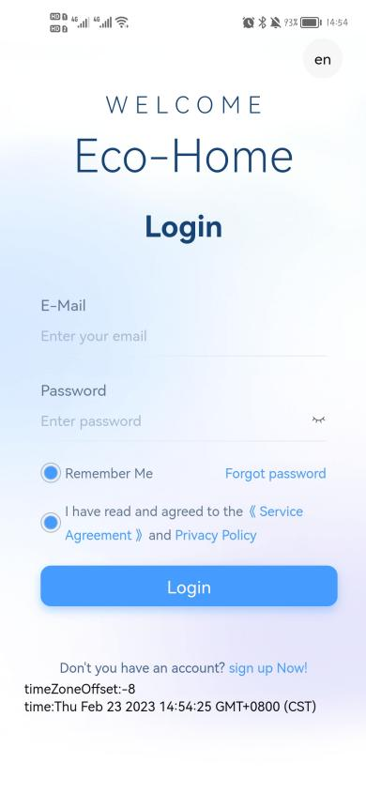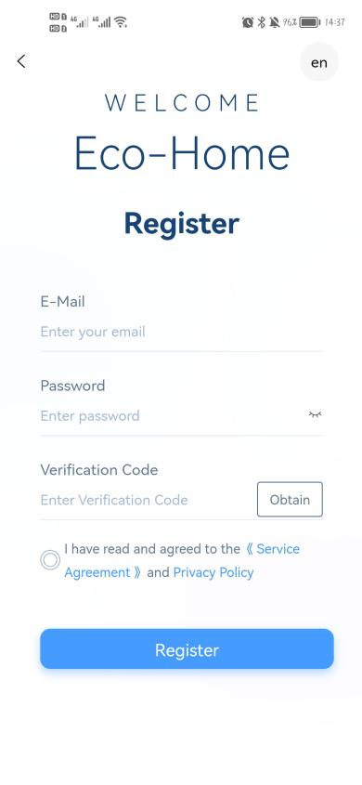

## Add Device

**Step 1:**

Turn on the phone's Bluetooth and Wi-Fi function, then connect to the Wi-Fi . The Wi-Fi must be able to connect to the Internet normally.

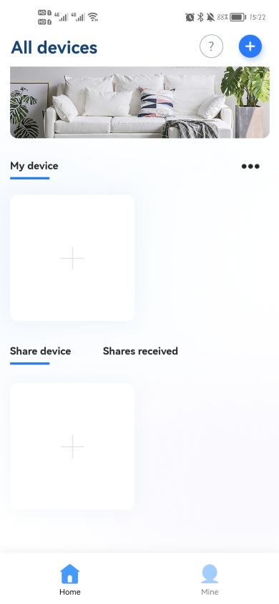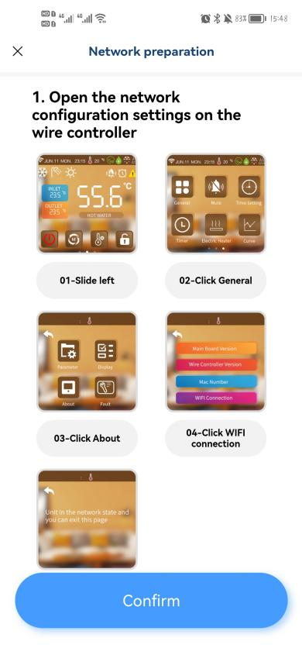

**Step 2:**

Choose Wi-Fi and enter the password.

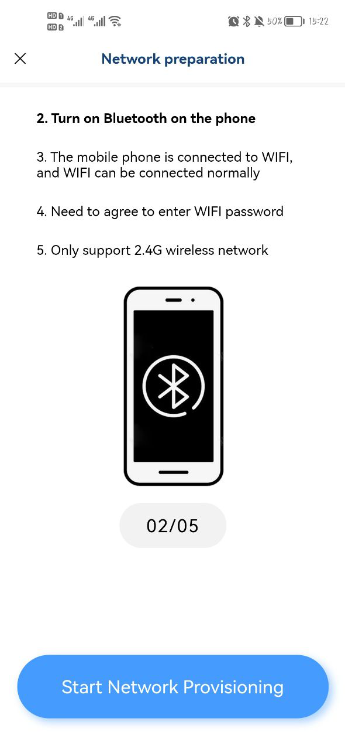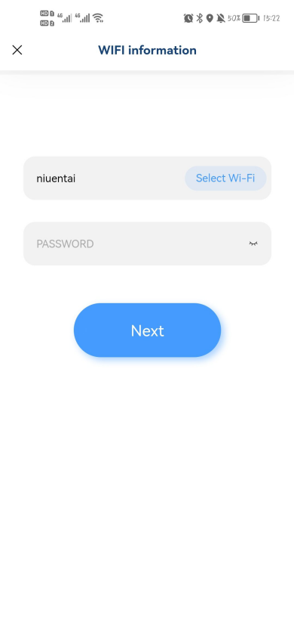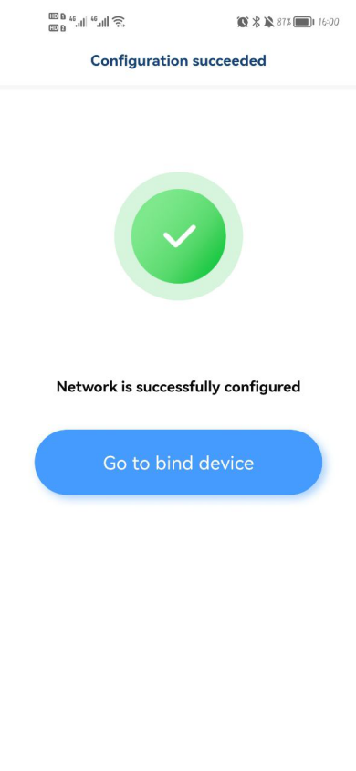

**Step 3:**

After successful networking, then scan the machine sticker QR code or enter the serial number to bind the unit.Return to the main page after successful binding.

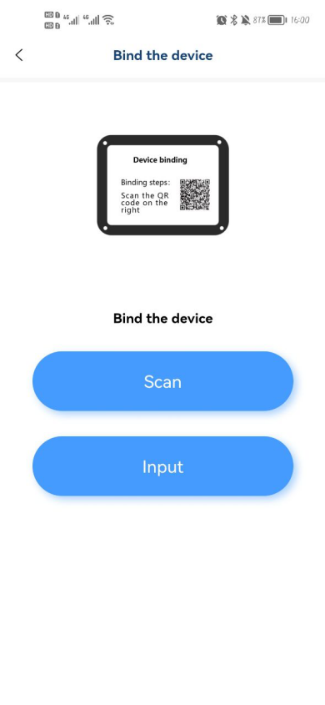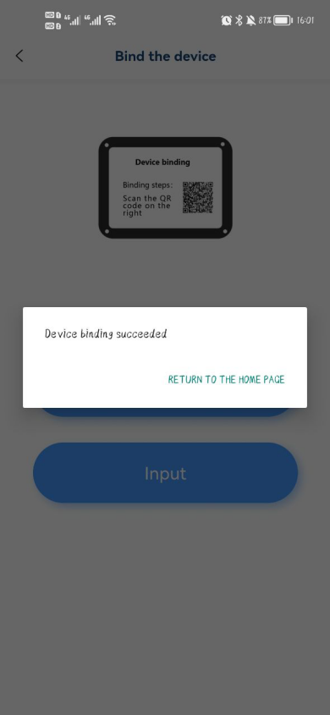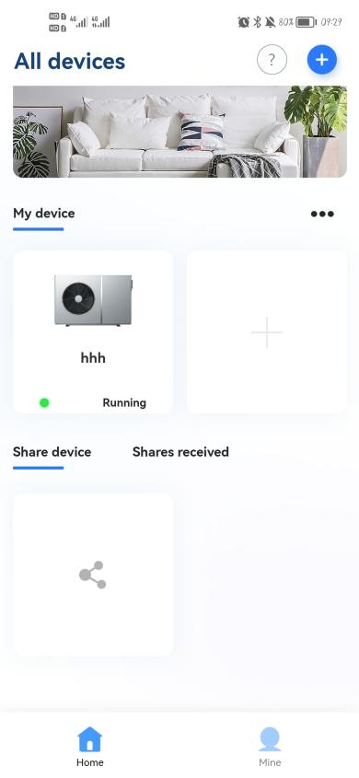

* **Device sharing**

Click "share device", click the unit you want to share, click "Add a share", enter the shared account information, and confirm the share.

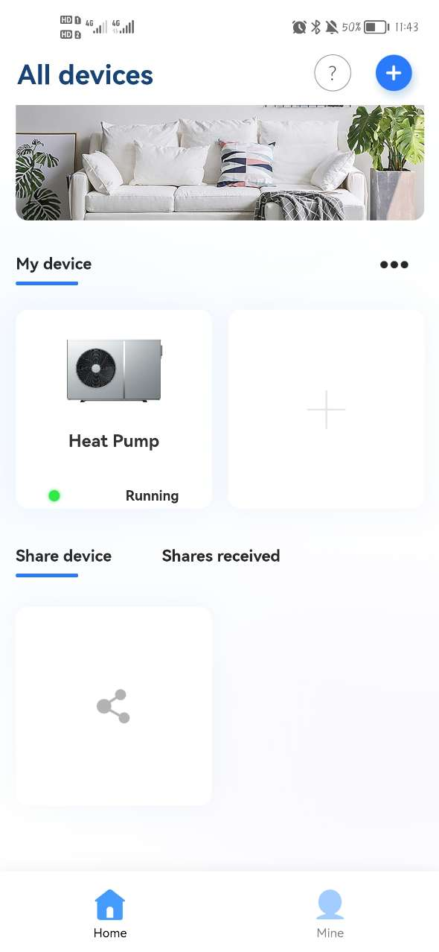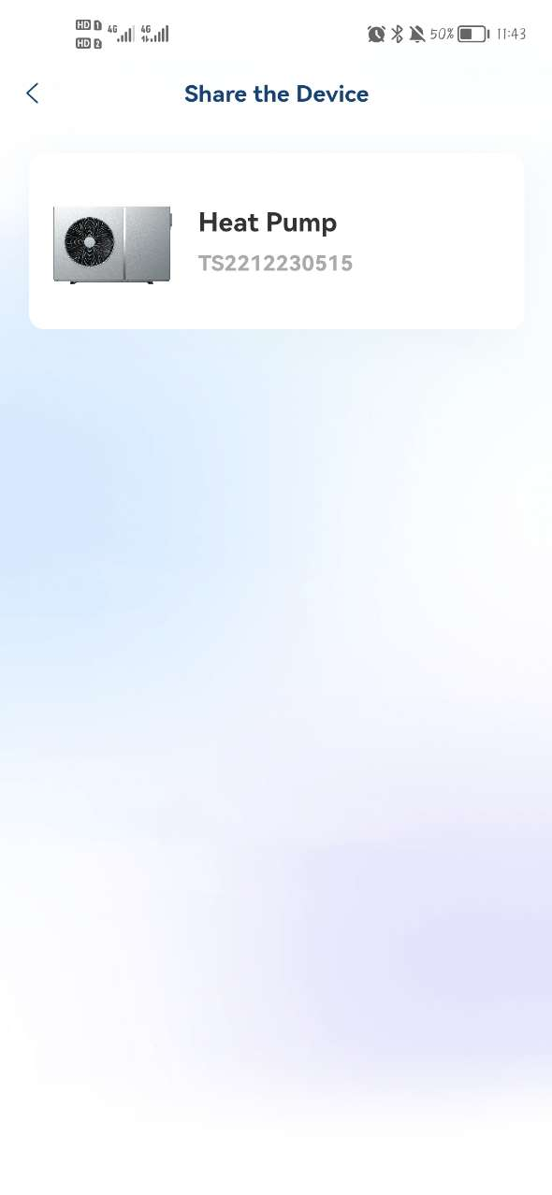

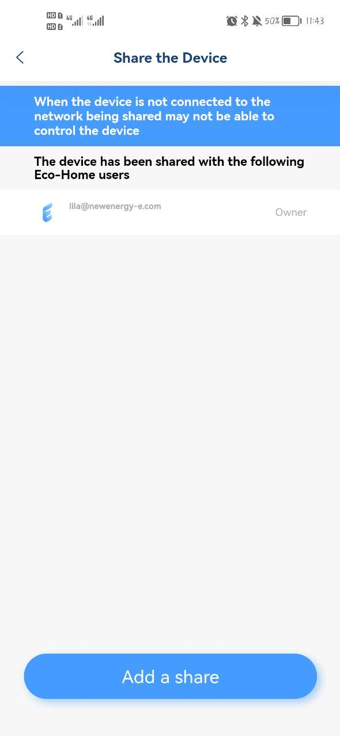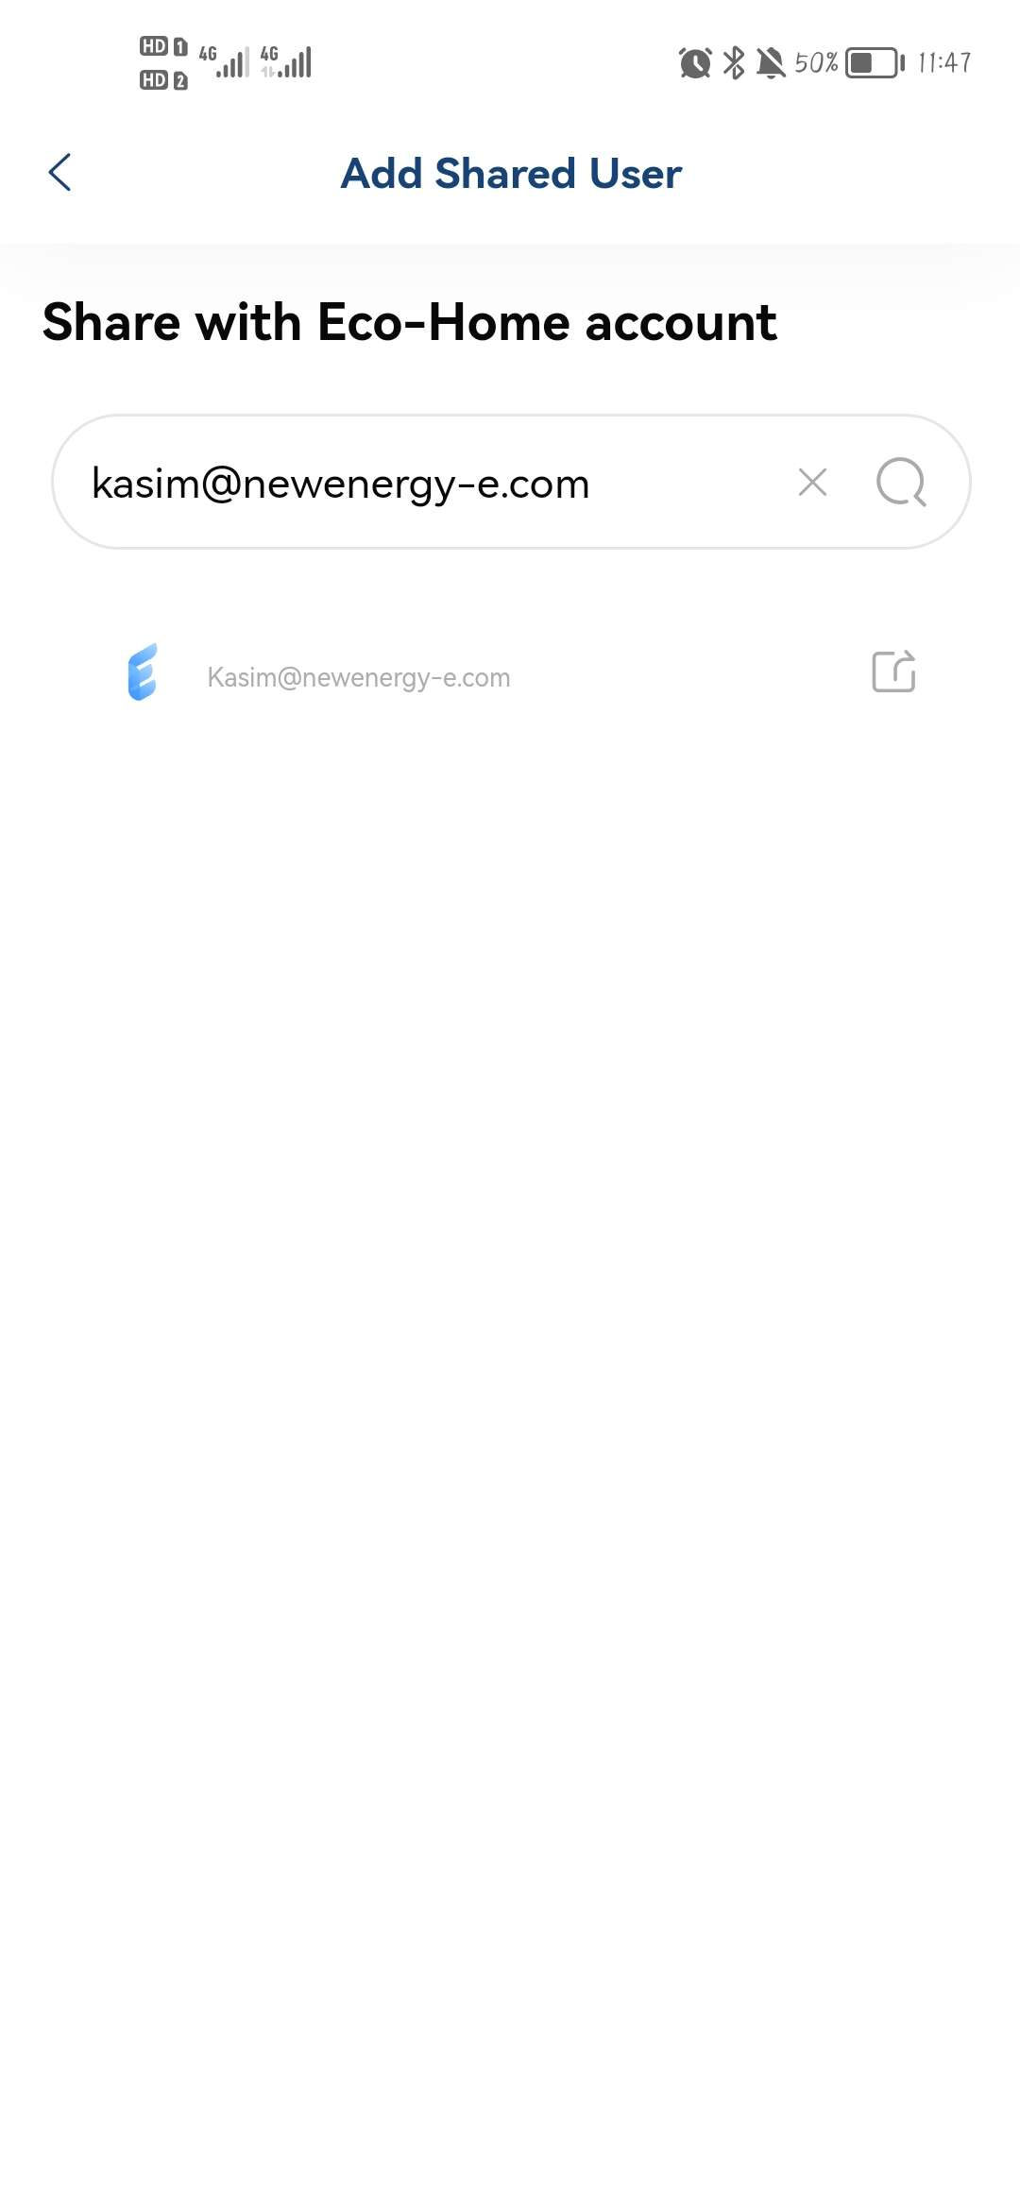

## Software Function Operation

* After the device is bound successfully, enter the operation interface of “Eco-Home” (Device name, modifiable)
* In the main interface, click the unit to enter the operation interface.

1. **Heating & Cooling**

31393935333436313b31393936353331323bcafdd7d631393935333436313b31393936353331313bcafdd7d6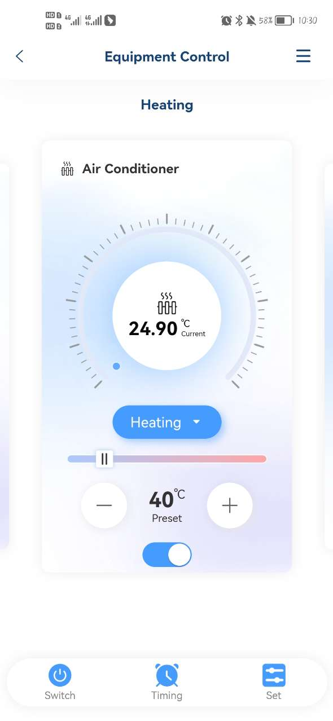31393935333436313b31393936353331333bcafdd7d6

1. Current Temperature
2. Mode Settings
3. Target Temperature Setting
4. ON/OFF
5. Total ON/OFF
6. Timer ON/OFF
7. Set
8. More Settings
9. **Hot Water**

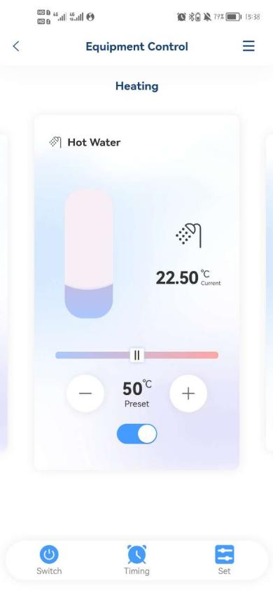

1. Current Temperature
2. Target Temperature Setting
3. ON/OFF
4. **Floor Heating**

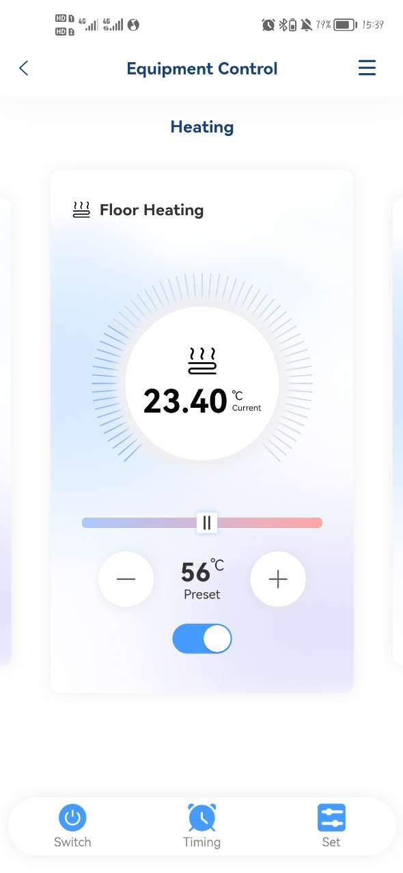

1. Current Temperature
2. Target Temperature Setting
3. ON/OFF

## Modify Device Name / Delete Device

Click in the following order to enter device details, and click "Device Name" to rename the device. Click "Delete the Device" to remove the device.

 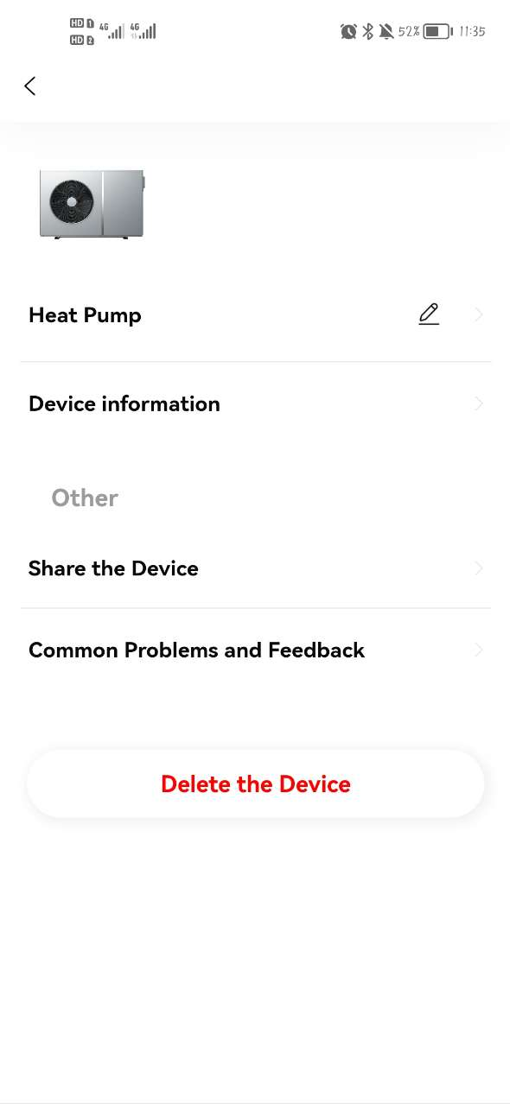

## Mode settings

Click to select the mode you need to set.

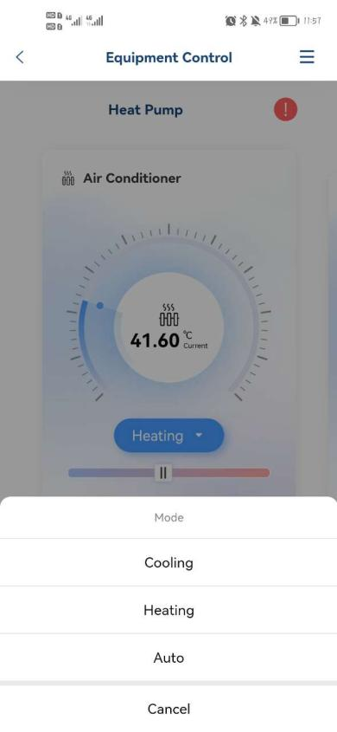

## Timing

Click "Timing", then click "+", set the timer and save it.

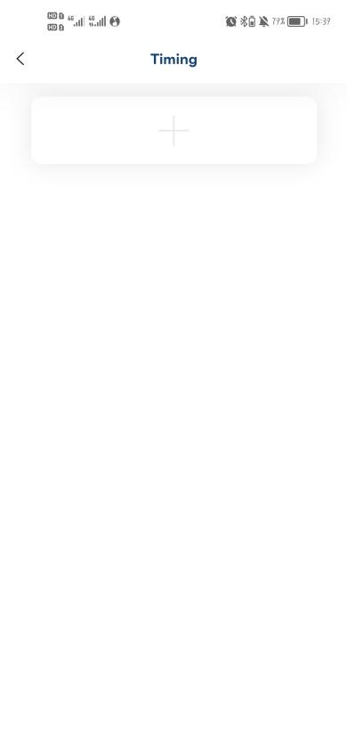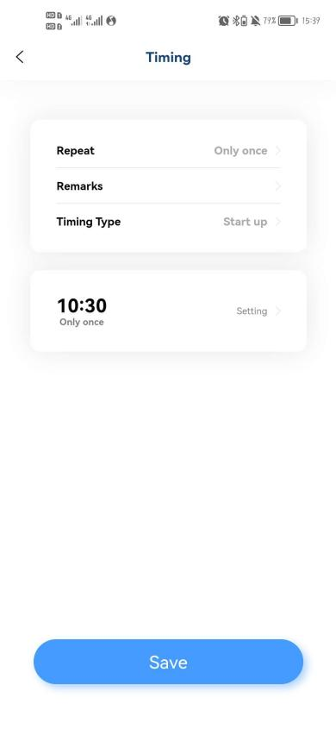

## Set Parameters

1. **Set Target Temp.**

Support to modify the content of the parameters is: Hot water target temperature, Cooling target temperature, Heating target temperature, Floor heating target temperature, and temperature units (in the modification of temperature units, the controller will re-read the main board and upload it to the APP one by one).

**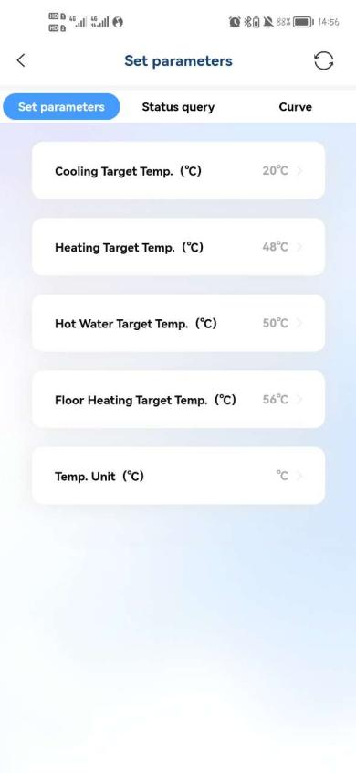**

1. **Status Query**

You can query the system status and module status.

**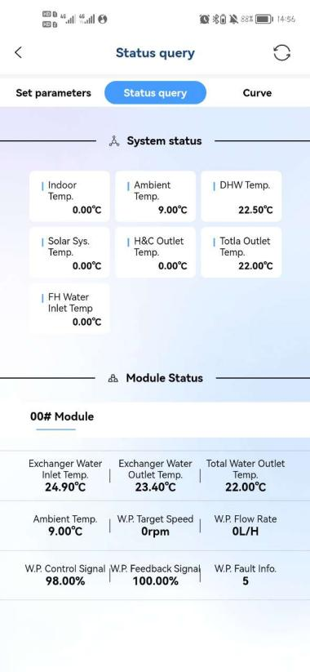**

1. **Temperature curve.**

The current curve shows the temperature respectively: Exchanger water outlet Temperature, Exchanger water inlet Temperature, Ambient Temperature, DHW Temperature. Real-time curve updates.

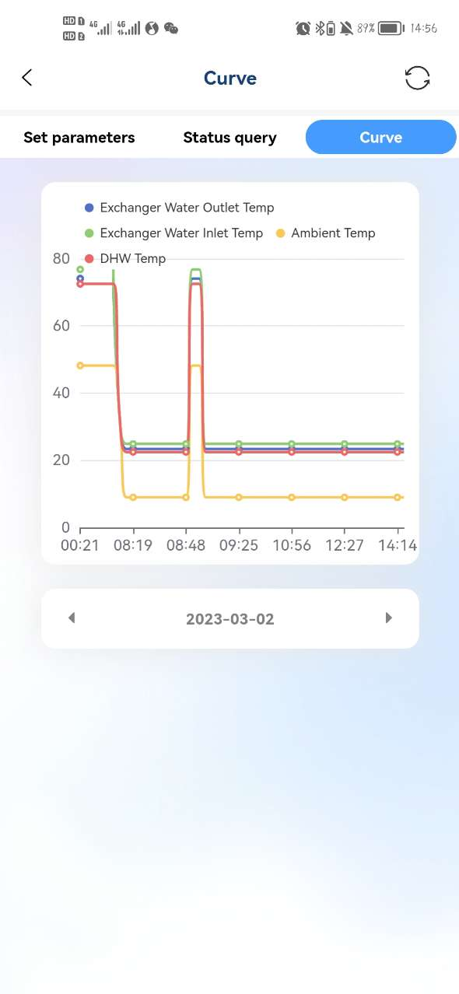

## Mine

Click "Mine" for user information, commom problems, about, and logout.

